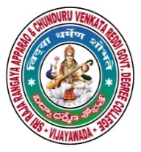 | SRR & CVR GOVERNMENT DEGREE COLLEGE  (AUTONOMOUS)  VIJAYAWADA, KRISHAN DIST., A.P  NAAC B+GRADE(CGPA:2.60) | 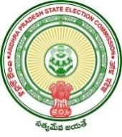

TELUGU LANGUAGE DAY
Date: 29-8-2020
- Telugu language day celebrations on SRR & CVR college (A), Vijayawada

- Resource person: Principal Dr. Illa Ravi,HOD’s of all departments and respected Lecturers .

- Chief Patron: Serrisetti Satyanarayana , professor in Telugu,.

- Events: poetry and write up students participated, apriciate ragava Ganesh in online.
Telugu language day was celebrated on 29-08-2020 at SRR & CVR GDC(A)College,VJA. On this occasion, the Principal Dr. Illa Ravi spoke on the importance of Telugu language and the contribution of Gidugu Venkata Ram Murthy towards Telugu language. The Chief guest was Serrisetti Satyanarayana garu, professor in Telugu, spoke on the history of Telugu Language and its importance. Poetry recitation and Poetry writing competitions were conducted and winners were awarded with certificates and prizes.

